

Alliance School of Advanced Computing

BTECH CSE – DA

VIth Semester

Software Engineering and Agile Development (6CS 1016)

Lab Batch Details

|  |  |  |  |  |
| --- | --- | --- | --- | --- |
| **S. No** | **Student Name** | **Role** | **Signature** | **Project Title** |
| **1** | **Vaishali** | **Project Manager** |  | **SprintPower: Agile-Based Live Energy Tracker** |
| **2** | **Mandara K N** | **Documentation Lead** |  |
| **3** | **Ramya S Uliger** | **Documentation Lead** |  |
| **4** | **Anusha K** | **Lead Developer** |  |
| **5** | **Sanjana Gadagi** | **QA Lead** |  |
|  |  |  |  |  |

Project Manager Email Id & Cell Phone Number:vaishalibtech23@ced.alliance.edu.in(96066 58544)

Problem Statement:

**Power cuts and high electricity bills with no insights**

Frequent power cuts and increasing electricity bills have become major concerns for households, commercial buildings, and industries. Despite the growing dependence on electrical appliances and digital infrastructure, most users lack proper insights into their real-time energy consumption. Electricity bills are usually provided on a monthly basis, offering only cumulative data, which makes it difficult for users to understand usage patterns, identify energy wastage, or take timely corrective actions. As a result, consumers often experience unexpected bill surges without knowing the underlying causes.

Additionally, unplanned power outages disrupt daily activities, productivity, and essential services. Existing systems rarely provide advance warnings or predictive insights regarding power cuts, leaving users unprepared. The absence of intelligent monitoring tools also limits the ability to optimize energy usage during peak and non-peak hours. This gap between energy consumption and actionable insights leads to inefficient electricity usage, financial strain, and inconvenience.

Therefore, there is a strong need for a smart energy monitoring and analysis system that can provide real-time consumption data, detect abnormal usage patterns, predict possible power interruptions, and help users manage electricity more efficiently. Such a system would empower users to make informed decisions, reduce energy wastage, lower electricity costs, and improve overall energy reliability.

**1. Project Selection & Team Formation - Choose project and assign roles**

**Project Title**

**SprintPower : Agile-Based Live Energy Tracker**

**Project Selection Rationale**

The project was selected to address real-world issues related to frequent power cuts and rising electricity bills. The lack of real-time energy consumption insights and predictive power outage alerts creates inefficiencies and inconvenience for users. SprintPower aims to provide actionable energy analytics, live monitoring, and outage predictions using an agile development approach.

**Team Formation**

The team was formed based on individual strengths to ensure effective collaboration and agile delivery.

|  |  |  |
| --- | --- | --- |
| **Team Member** | **Role** | **Responsibility** |
| Vaishali | Project Manager | Planning, coordination, sprint management |
| Mandara K N | Documentation Lead | Project documentation & reports |
| Ramya S Uliger | Documentation Lead | Requirement & process documentation |
| Anusha K | Lead Developer | System design & development |
| Sanjana Gadagi | QA Lead | Testing, quality assurance |

**2. Team Agreement Creation - Create team agreement with working norms**

**Purpose**

To define working norms, responsibilities, and collaboration standards for smooth project execution.

**Team Working Norms**

* All members must attend sprint meetings regularly
* Tasks are assigned through mutual discussion
* Daily progress updates via team communication channel
* Respect deadlines and peer contributions

**Communication Guidelines**

* Primary communication: WhatsApp / Google Meet
* Emergency updates must be informed immediately
* Weekly sprint review meetings

**Conflict Resolution**

* Issues discussed openly within the team
* Escalation to Project Manager if unresolved
* Mutual respect maintained at all times

**3. Problem Statement Development - Define project title, problem, solution, target users, and value proposition**

**Project Title**

SprintPower: Agile-Based Live Energy Tracker

**Problem Definition**

Users receive electricity bills monthly without real-time insights, making it hard to track consumption patterns, identify wastage, or anticipate power cuts. This leads to unexpected bill surges and disruptions.

**Proposed Solution**

SprintPower provides:

* Real-time electricity usage tracking
* Power outage alerts and predictions
* Usage pattern analysis
* Cost-saving insights

**Target Users**

* Residential households
* Commercial buildings
* Small industries
* Facility managers

**Value Proposition**

* Reduced electricity costs
* Improved energy efficiency
* Better preparedness for power cuts
* Data-driven energy decisions

**4. Stakeholder Analysis - Identify primary and secondary stakeholders**

Stakeholder analysis helps identify individuals or groups who are directly or indirectly affected by the project and understand their role in project success.

**Primary Stakeholders**

Primary stakeholders have a direct interaction with the system and influence its outcomes.

* **End Users (Households, Commercial Users, Industries):**  
   They use the system to monitor electricity usage, receive alerts, and reduce energy costs.
* **Project Team Members:**  
   Responsible for planning, development, documentation, testing, and delivery of the system.
* **Project Manager:**  
   Oversees sprint planning, task allocation, progress tracking, and ensures timely completion.

**Secondary Stakeholders**

Secondary stakeholders influence or support the project indirectly.

* **Electricity Utility Providers:**  
   Provide power data and infrastructure context; not directly involved in system usage.
* **Faculty / Evaluators:**  
   Evaluate project documentation, process, and outcomes for academic assessment.
* **System Administrators:**  
   Maintain system availability and manage backend operations.

**5. Stakeholder Interests Documentation - Document stakeholder interests and influence**

This section documents what each stakeholder expects from the project and how much influence they have on project decisions.

|  |  |  |
| --- | --- | --- |
| **Stakeholder** | **Key Interests** | **Influence Level** |
| End Users | Accurate real-time energy data, reduced bills, reliability | High |
| Project Manager | On-time delivery, smooth collaboration | High |
| Developers | Clear requirements, stable scope | Medium |
| Documentation Team | Complete and accurate records | Medium |
| QA Team | Bug-free, reliable system | Medium |
| Faculty | Learning objectives met, structured documentation | High |
| Electricity Providers | Efficient power usage insights | Low |

**6. Stakeholder Register Creation - Create formal stakeholder register**

The stakeholder register is a formal document that records essential information about all stakeholders.

|  |  |  |  |  |
| --- | --- | --- | --- | --- |
| **Stakeholder ID** | **Stakeholder Name** | **Role** | **Interest Description** | **Influence** |
| ST-01 | End Users | Consumers | Want insights into power usage and cost savings | High |
| ST-02 | Project Manager | Coordinator | Ensures project meets objectives and deadlines | High |
| ST-03 | Development Team | Builders | Focus on system performance and functionality | Medium |
| ST-04 | QA Team | Testers | Ensures quality and system reliability | Medium |
| ST-05 | Documentation Team | Record Keepers | Maintain accurate project records | Medium |
| ST-06 | Faculty | Evaluators | Academic compliance and evaluation | High |

**7. Scope Definition - In-Scope - Document in-scope features**

Scope definition identifies what is included in the current phase of the project to avoid ambiguity and scope creep.

**In-Scope Features**

* The following functionalities are included in SprintPower:
* Real-time electricity consumption monitoring
* Visualization of energy usage through charts and dashboards
* Daily, weekly, and monthly usage reports
* Power outage alerts and notifications
* Detection of abnormal energy usage patterns
* User authentication and profile management
* Secure storage of energy consumption data
* Web-based application development
* Agile sprint-based feature delivery
* Basic prediction of possible power interruptions
* These features ensure that SprintPower meets its objective of providing actionable energy insights to users.

**8. Scope Definition - Out-of-Scope - Document out-of-scope features**

Out-of-scope items define what will **not** be implemented in the current version of the project. This helps manage expectations and keeps the project feasible.

**Out-of-Scope Features**

* Installation or maintenance of physical smart meters
* Integration with government electricity billing systems
* Automatic electricity bill payment functionality
* Mobile application development (Android/iOS)
* Appliance-wise energy consumption tracking
* Support for multiple electricity boards
* Advanced AI-based forecasting models
* Commercial deployment and large-scale maintenance
* Legal and regulatory compliance implementation
* These features may be considered for future enhancements but are excluded from the current academic project.

## **9. Scope Boundaries Document – Create Scope Boundaries Document**

**Purpose**

* The purpose of this document is to clearly define the limits of the SprintPower system.
* It helps prevent unnecessary feature expansion and controls project complexity.

**System Inclusions (Within Scope)**

* The system will provide real-time monitoring of electricity consumption.
* It will generate dashboards and charts to visualize usage trends.
* The system will send outage alerts and abnormal usage notifications.
* It will allow users to register, log in, and manage profiles securely.
* It will generate downloadable energy usage reports.

**System Exclusions (Outside Scope)**

* The project will not include installation or maintenance of smart meters.
* Integration with government billing systems is excluded.
* Automatic bill payment is not supported.
* Appliance-wise tracking is not implemented.
* Mobile application development is excluded.

**Benefits of Scope Boundaries**

* Prevents scope creep and uncontrolled development.
* Ensures better planning and efficient resource usage.
* Helps deliver the project on time with defined objectives.

## **10. SRS Introduction Section – Purpose, Scope, Definitions/Acronyms**

**Purpose of the SRS Document**

* The document describes system requirements before development begins.
* It serves as a reference for developers, testers, and evaluators.
* It ensures a common understanding of system objectives.

**Scope of the System**

* The system provides real-time energy monitoring and reporting.
* It offers outage alerts and cost-saving insights.
* It supports user authentication and dashboard visualization.

**Intended Audience**

* Developers responsible for implementation.
* Testers validating system behavior.
* Project managers and faculty evaluators reviewing progress.

**Definitions and Acronyms**

* SRS – Software Requirements Specification
* UI – User Interface
* API – Application Programming Interface
* DB – Database
* IoT – Internet of Things

## **11. SRS Overall Description – Product Perspective, Functions, Users, Constraints**

**Product Perspective**

* SprintPower is a web-based standalone system.
* It follows a modular architecture for scalability.
* Future integration with smart meters is possible.

**Main System Functions**

* Monitor real-time electricity consumption.
* Display usage trends using charts and dashboards.
* Generate daily, weekly, and monthly reports.
* Send outage alerts and abnormal usage notifications.

**User Characteristics**

* Residential users track household consumption.
* Commercial users and facility managers monitor multiple units.
* System administrators manage configuration and security.

**System Constraints**

* Depends on internet connectivity.
* Limited hardware integration in academic version.
* Browser compatibility restrictions.
* Academic timelines limit development duration.

## **12. Functional Requirements Documentation – FR-01 to FR-n**

**FR-01: User Registration**

* The system shall allow users to create accounts using valid details.
* It shall validate mandatory fields before registration.

**FR-02: Login Authentication**

* The system shall provide secure login access.
* It shall restrict unauthorized users.

**FR-03: Real-Time Usage Display**

* The system shall display current electricity usage dynamically.
* It shall refresh data automatically.

**FR-04: Usage Visualization**

* The system shall generate charts for usage trends.
* It shall allow viewing historical data.

**FR-05: Outage Alerts**

* The system shall notify users about power outages.
* It shall display alert messages on the dashboard.

**FR-06: Abnormal Usage Detection**

* The system shall detect unusual consumption patterns.
* It shall notify users when abnormal usage occurs.

**FR-07: Report Generation**

* The system shall generate downloadable usage reports.
* It shall include summaries and graphical data.

## **13. Non-Functional Requirements Documentation – NFR-01 to NFR-04**

**NFR-01: Performance**

* The system should update data with minimal delay.
* It should handle multiple users efficiently.

**NFR-02: Security**

* The system must provide secure authentication.
* It must encrypt stored data.
* It must prevent unauthorized access.

**NFR-03: Usability**

* The system should have a simple and intuitive interface.
* It should provide easy navigation and clear instructions.

**NFR-04: Reliability**

* The system should maintain high availability.
* It should ensure data accuracy and consistency.
* It should recover quickly from failures.

## **14. Use Case Diagrams Creation – Create Use Case Diagrams**

**Purpose of Use Case Diagrams**

* Illustrate interactions between users and the system.
* Define user roles and responsibilities.
* Clarify system behavior visually.

**Primary Actors**

* End User
* Facility Manager
* System Administrator

**End User Use Cases**

* Register and log into the system.
* View real-time electricity usage.
* View charts and reports.
* Receive outage alerts and notifications.

**Administrator Use Cases**

* Manage user accounts.
* Configure system settings.
* Monitor system performance and security.

**Importance of Diagrams**

* Helps developers understand system flow.
* Supports testing and validation.
* Defines system boundaries clearly.

## **15. Glossary Development – Create Project Glossary**

**Purpose of the Glossary**

* Provides clear definitions of technical and domain terms.
* Ensures consistent understanding among stakeholders.
* Reduces ambiguity in documentation and development.

**Key Terms and Definitions**

* **Real-Time Monitoring** – Continuous tracking of electricity usage without delay.
* **Outage Alert** – Notification of predicted or detected power interruption.
* **Dashboard** – Main interface displaying energy data and alerts.
* **Consumption Pattern** – Trend of electricity usage over time.
* **Abnormal Usage** – Unusual or unexpected consumption behavior.
* **Facility Manager** – User managing electricity usage for multiple buildings.
* **System Administrator** – Technical user maintaining system operations and security.
* **Usage Report** – Document summarizing electricity consumption data.

**Importance of Glossary**

* Helps new team members understand system terminology.
* Ensures accurate interpretation of requirements.
* Improves communication throughout the project lifecycle.

**16. Project Charter Submission - Deliver project charter document**

### **Project Title**

**SprintPower: Agile-Based Live Energy Tracker**

### **Project Charter**

#### **Introduction**

A Project Charter is a formal document that authorizes the existence of a project and provides a clear understanding of its objectives, scope, stakeholders, and responsibilities. It acts as a reference point throughout the project lifecycle and ensures that all team members share a common vision and direction.

The **SprintPower: Agile-Based Live Energy Tracker** project aims to address the growing issues of frequent power cuts and high electricity bills by providing real-time energy consumption monitoring and predictive insights using Agile development principles.

#### **Project Purpose**

The purpose of this project is to design and develop a smart, agile-based system that enables users to monitor electricity usage in real time, detect abnormal consumption patterns, predict power outages, and receive optimization suggestions. This will help users reduce energy wastage, lower electricity costs, and improve preparedness for power interruptions.

#### **Project Objectives**

* To monitor electricity consumption in real time
* To provide a live energy usage dashboard
* To detect unusual or excessive power consumption
* To predict possible power outages
* To notify users about bill spikes and power anomalies
* To develop the system using Agile methodology for continuous improvement

#### **Project Scope**

**In Scope:**

* Real-time energy usage monitoring
* Usage analytics and visualization
* Alerts for abnormal consumption
* Predictive insights for power cuts
* Web or mobile-based user interface
* Agile sprint-based development

**Out of Scope:**

Direct control of electrical supply

* Physical installation of power infrastructure
* Billing system integration with electricity boards

#### **Stakeholders**

* Project Manager
* Development Team
* Documentation Team
* Quality Assurance Team
* End Users (Households / Commercial users)
* Academic Evaluators

#### **Project Team and Roles**

* **Project Manager:** Oversees project planning, execution, and coordination
* **Documentation Lead:** Prepares project documentation and reports
* **Lead Developer:** Designs and implements the application
* **QA Lead:** Ensures quality, testing, and validation

#### **Assumptions**

* Users have access to internet connectivity
* Energy data can be collected through smart meters or simulated inputs
* Agile tools and frameworks are available

#### **Constraints**

* Limited project timeline
* Academic evaluation requirements
* Resource and budget limitations

#### **Project Deliverables**

* Project Charter Document
* Requirement Specification
* Sprint Plans and Backlogs
* Working Prototype
* Test Reports
* Final Project Report

#### **Success Criteria**

* Accurate real-time energy tracking
* Timely alerts and notifications
* Predictive accuracy for power cuts
* User-friendly interface
* Successful completion of Agile sprints

**17. Stakeholder Register Submission – Submit Stakeholder Register**

**Stakeholder Register**

#### **Introduction**

A Stakeholder Register is a document that identifies all individuals or groups involved in or affected by a project. It helps in understanding stakeholder interests, influence, and communication needs. Maintaining a stakeholder register ensures effective coordination, transparency, and successful project execution.

For the **SprintPower** project, the stakeholder register outlines the key stakeholders involved in planning, development, documentation, testing, and evaluation of the system.

### **Stakeholder Identification Table**

|  |  |  |  |  |
| --- | --- | --- | --- | --- |
| **Stakeholder Name / Group** | **Role** | **Interest** | **Influence** | **Responsibility** |
| Project Manager | Project Head | High | High | Planning, coordination, and monitoring progress |
| Development Team | Developers | High | High | Design and implementation of the system |
| Documentation Team | Documentation Leads | Medium | Medium | Preparing reports and project documents |
| QA Team | Quality Assurance | Medium | Medium | Testing and validating the system |
| End Users | Consumers | High | Medium | Using the system and providing feedback |
| Faculty Guide | Academic Mentor | High | High | Guidance, review, and evaluation |
| Institution | Academic Authority | Medium | High | Approval and assessment |
| Utility Providers (Assumed) | Data Source | Low | Low | Providing energy data (simulated/assumed) |

#### **Stakeholder Communication Plan**

* **Project Manager:** Regular sprint meetings and reviews
* **Development Team:** Daily stand-ups and sprint planning
* **Documentation Team:** Weekly documentation updates
* **QA Team:** Test review meetings after each sprint
* **Faculty Guide:** Periodic progress reviews
* **End Users:** Feedback through surveys or testing sessions

#### **Stakeholder Expectations**

* Clear project goals and scope
* Timely completion of milestones
* Quality implementation following Agile principles
* Accurate documentation and reports

# **18. Complete SRS Document – Software Requirements Specification**

### **Project Title:**

**SprintPower: Agile-Based Live Energy Tracker**

## **1. Introduction**

### **1.1 Purpose**

This Software Requirements Specification (SRS) document provides a detailed description of the functional and non-functional requirements of the **SprintPower: Agile-Based Live Energy Tracker** system. It serves as a reference for developers, testers, project managers, and stakeholders to understand the system requirements clearly.

### **1.2 Scope**

SprintPower is a smart energy monitoring system designed to provide real-time electricity usage insights, detect abnormal consumption patterns, predict possible power outages, and notify users about energy inefficiencies. The system follows Agile development methodology for flexibility and continuous improvement.

### **1.3 Definitions, Acronyms, and Abbreviations**

* **SRS:** Software Requirements Specification
* **UI:** User Interface
* **QA:** Quality Assurance
* **Agile:** Iterative software development methodology
* **Dashboard:** Visual interface displaying data

### **1.4 References**

* IEEE 830 SRS Standards
* Agile Development Principles
* Software Engineering Textbooks

### **1.5 Overview**

This document is organized into overall system description, functional requirements, non-functional requirements, system interfaces, and constraints.

## **2. Overall Description**

### **2.1 Product Perspective**

SprintPower is a standalone web or mobile-based application that processes real-time or simulated energy data and presents analytics through a user-friendly dashboard.

### **2.2 Product Functions**

* Monitor real-time electricity consumption
* Display usage statistics
* Detect abnormal usage patterns
* Predict power outages
* Send alerts and notifications
* Generate usage reports

### **2.3 User Classes and Characteristics**

|  |  |
| --- | --- |
| **User Type** | **Description** |
| Admin | Manages system and data |
| End User | Views energy usage and alerts |
| QA Team | Tests system functionality |
| Faculty Evaluator | Reviews project |

### **2.4 Operating Environment**

* Web browser / Mobile device
* Internet connectivity
* Backend server (Node.js / Python)

### **2.5 Design and Implementation Constraints**

* Limited academic project duration
* Simulated or smart meter data
* Resource constraints

### **2.6 Assumptions and Dependencies**

* Users have basic technical knowledge
* Internet connectivity is available
* Energy data source is reliable

## **3. System Features and Functional Requirements**

### **3.1 User Registration and Login**

* Users can register with valid credentials
* Secure login authentication

### **3.2 Real-Time Energy Monitoring**

* Display live electricity consumption
* Update usage data dynamically

### **3.3 Energy Usage Dashboard**

* Graphical representation of usage
* Daily, weekly, and monthly reports

### **3.4 Abnormal Usage Detection**

* Identify unusual power consumption
* Notify users instantly

### **3.5 Power Cut Prediction**

* Analyze past patterns
* Predict possible outages

### **3.6 Alerts and Notifications**

* Bill spike alerts
* Usage anomaly notifications

### **3.7 Report Generation**

* Downloadable usage reports
* Visual charts and summaries

## **4. External Interface Requirements**

### **4.1 User Interface**

* Simple and responsive UI
* Easy navigation

### **4.2 Hardware Interface**

* Smart meters (optional / simulated)

### **4.3 Software Interface**

* Database for storing energy data
* Backend API integration

### **4.4 Communication Interface**

* Internet-based data transmission

## **5. Non-Functional Requirements**

### **5.1 Performance Requirements**

* Real-time data updates
* Fast response time

### **5.2 Security Requirements**

* Secure login authentication
* Data encryption

### **5.3 Reliability**

* System availability 24/7
* Minimal downtime

### **5.4 Usability**

* Easy-to-use interface
* Minimal learning curve

### **5.5 Scalability**

* Support multiple users
* Handle increased data volume

### **5.6 Maintainability**

* Modular code structure
* Easy updates using Agile sprints

## **6. System Models**

* Use Case Diagram
* Data Flow Diagram (DFD)
* Sequence Diagram

## **7. Agile Development Approach**

* Sprint-based development
* Continuous feedback
* Incremental feature delivery

## **8. Testing Requirements**

* Unit testing
* Integration testing
* System testing
* User acceptance testing

## **9. Future Enhancements**

* AI-based consumption prediction
* Integration with electricity boards
* Mobile app version

## **10. Conclusion**

This SRS document defines the complete requirements of the **SprintPower** system. It ensures clarity, consistency, and proper guidance for development, testing, and evaluation while following Agile principles.

**19. Requirements Sign-off - Get signed-off requirements by instructor**

### **Objective**

The purpose of the requirements sign-off is to formally approve and freeze the project requirements before moving to the design phase. This ensures that all stakeholders agree on what will be developed and avoids misunderstandings or scope changes later.

### **Description**

After completing requirements gathering and documentation for the **SprintPower: Agile-Based Live Energy Tracker**, the finalized requirements document was reviewed by the instructor. The document includes the problem statement, functional requirements, non-functional requirements, scope definitions, and stakeholder details.

During the review process, the instructor verified:

* Clarity and completeness of requirements
* Alignment with the problem statement
* Feasibility within the academic timeline
* Proper application of software engineering principles

Once reviewed, the instructor provided approval, confirming that the requirements are correct and complete. After sign-off, the requirements are considered **baselined**, and further changes require formal approval.

### **Outcome**

* Requirements approved by instructor
* Authorization to proceed to system design phase
* Reduced risk of requirement ambiguity

**Sign-off Authority:** Course Instructor  
 **Status:** Approved

# **Exercise 2: System Design with CASE Tools**

**20.CASE Tool Setup - Install and configure StarUML or Visual Paradigm**

### **Objective**

To install and configure a CASE (Computer-Aided Software Engineering) tool for system modeling and design.

### **Tool Selected**

**StarUML / Visual Paradigm**

### **Description**

A CASE tool is required to design UML diagrams such as use case, class, sequence, and activity diagrams. For the SprintPower project, StarUML (or Visual Paradigm) was selected due to its user-friendly interface and support for UML standards.

### **Steps Performed**

1. Downloaded the CASE tool from the official website
2. Installed the software on team members’ systems
3. Verified tool compatibility with the operating system
4. Configured UML diagram templates
5. Tested diagram creation and export options

### **Outcome**

* CASE tool successfully installed and configured
* Team ready to begin system modeling

**21. Team Workspace Setup**  **team workspace for CASE tool**

### **Objective**

To enable collaborative system design by setting up a shared workspace for the CASE tool.

### **Description**

A team workspace was created to ensure consistency and collaboration among team members during system design. All design files are stored in a shared repository to avoid duplication and version conflicts.

### **Workspace Setup Details**

* Shared folder created using Google Drive / GitHub
* Common project file maintained for UML diagrams
* Naming conventions followed for files and diagrams
* Access provided to all team members

### **Benefits**

* Improved collaboration
* Centralized design files
* Better version control
* Reduced design inconsistencies

# **22. Project Structure Creation (CASE Tool)**

### **Objective**

To create a well-organized project structure inside the CASE tool for effective system design.

### **Description**

A structured project layout was created within the CASE tool to manage different UML diagrams efficiently. This structure helps in better understanding, navigation, and maintenance of the system design.

### **Project Structure Includes**

* Project Name: **SprintPower**
* Use Case Diagrams
* Class Diagrams
* Sequence Diagrams
* Activity Diagrams
* Deployment Diagrams

Each diagram type is stored in a separate folder or package within the CASE tool.

### **Outcome**

* Clear and organized design hierarchy
* Easy access to system models
* Improved readability and evaluation

**23. Actors Identification**

**Objective**

To identify all actors that interact with the SprintPower system.

**Description**

Actors represent external entities that interact with the system. Identifying actors is an essential step for creating use case diagrams and defining system boundaries.

**Identified Actors**

1. **User (Household / Commercial User)**
   1. Views real-time energy consumption
   2. Receives power cut alerts
   3. Accesses usage reports
2. **Admin**
   1. Manages user accounts
   2. Monitors system performance
   3. Handles data management
3. **System**
   1. Collects and processes energy data
   2. Generates alerts and predictions
   3. Stores and analyzes consumption data
4. **Electricity Data Source (External System)**
   1. Provides power usage input data
   2. Supports outage and load information

**Outcome**

* Actors clearly identified
* Foundation established for use case modeling
* Clear understanding of system interactions

## **24. Use Case Definition – Define 8–12 Core Use Cases**

**Core Use Cases for SprintPower**

* User Registration – Allows users to create a new account in the system.
* User Login – Allows users to securely access the system dashboard.
* View Real-Time Usage – Displays current electricity consumption values.
* View Usage Charts – Shows graphical representation of usage trends.
* Generate Usage Reports – Creates downloadable consumption reports.
* Receive Outage Alerts – Notifies users about power interruptions.
* Detect Abnormal Usage – Identifies unusual consumption behavior.
* View Cost Insights – Displays recommendations to reduce electricity costs.
* Manage Profile – Allows users to update personal information.
* Manage Users – Allows administrators to add, update, or remove users.

These use cases represent the main functionalities of the SprintPower system.

## **25. Use Case Relationships – Show Include / Extend Relationships**

**Include Relationships**

* User Login is included in View Real-Time Usage because authentication is required before accessing data.
* User Login is included in Generate Usage Reports to ensure authorized access.
* View Usage Charts includes Retrieve Usage Data for accurate visualization.

**Extend Relationships**

* Detect Abnormal Usage extends View Real-Time Usage when unusual patterns are found.
* Receive Outage Alerts extends Monitor Usage when power interruptions occur.
* View Cost Insights extends Generate Usage Reports for detailed analysis.

**Purpose of Relationships**

* Reduce duplication of common functionalities.
* Improve modular design of use cases.
* Clearly define optional and mandatory system behaviors.

## **26. Use Case Documentation – Preconditions, Flows, Postconditions**

### **Use Case: User Login**

**Preconditions**

* The user must have a registered account.
* The system must be available and online.

**Main Flow**

* User enters username and password.
* System validates credentials.
* System grants access to dashboard.

**Alternative Flow**

* If credentials are invalid, system displays error message.
* User is asked to re-enter login details.

**Postconditions**

* User is successfully logged into the system.
* User dashboard is displayed.

### **Use Case: View Real-Time Usage**

**Preconditions**

* User must be logged into the system.
* Usage data must be available from data source.

**Main Flow**

* User selects real-time usage option.
* System retrieves current consumption data.
* System displays updated usage values on dashboard.

**Alternative Flow**

* If data is unavailable, system shows temporary error message.

**Postconditions**

* Real-time consumption data is displayed to the user.

## **27. Class Identification – Identify Key Classes**

**Main System Classes**

* User
* FacilityManager
* SystemAdministrator
* EnergyData
* UsageReport
* Alert
* Dashboard
* AuthenticationManager
* CostAnalyzer

**Purpose of Class Identification**

* Represent real-world entities in the system.
* Define system structure and responsibilities.
* Support object-oriented system design.

## **28. Class Attributes and Methods Definition**

### **Class: User**

**Attributes**

* userID
* name
* email
* password
* role

**Methods**

* register()
* login()
* updateProfile()
* viewUsage()

### **Class: EnergyData**

### **Attributes**

* dataID
* timestamp
* consumptionValue
* sourceID

**Methods**

* fetchData()
* storeData()
* updateData()

### **Class: UsageReport**

**Attributes**

* reportID
* startDate
* endDate
* totalConsumption

**Methods**

* generateReport()
* downloadReport()
* viewReport()

### **Class: Alert**

**Attributes**

* alertID
* alertType
* message
* AlertTime
* **Methods**
* createAlert()
* sendAlert()
* displayAlert()

## **29. Class Relationships – Association, Aggregation, Inheritance**

**Association Relationships**

* User is associated with Dashboard to view energy data.
* User is associated with UsageReport to generate reports.

**Aggregation Relationships**

* Dashboard aggregates EnergyData to display usage information.
* FacilityManager aggregates multiple User objects for monitoring.

**Inheritance Relationships**

* FacilityManager inherits from User class.
* SystemAdministrator inherits from User class.

**Purpose of Class Relationships**

* Define interactions between system objects.
* Support code reuse and modular design.
* Represent system structure clearly in class diagrams.

**30. Sequence Diagrams Creation – Create 3–4 Critical Sequence Diagrams**

**Purpose of Sequence Diagrams**

* Show interaction between objects over time.
* Represent message flow during system execution.
* Help understand system behavior dynamically.

### **Sequence Diagram 1: User Login Process**

* User sends login request to AuthenticationManager.
* AuthenticationManager validates credentials.
* System returns login success or failure response.
* User dashboard is displayed after success.

### **Sequence Diagram 2: View Real-Time Usage**

* User requests real-time data from Dashboard.
* Dashboard requests data from EnergyData module.
* EnergyData retrieves current values from data source.
* Dashboard displays usage data to user.

### **Sequence Diagram 3: Generate Usage Report**

* User requests report generation.
* System retrieves historical usage data.
* UsageReport object generates report.
* System provides downloadable report to user.

### **Sequence Diagram 4: Outage Alert Notification**

* System monitors incoming outage data.
* Alert module creates alert message.
* System sends alert to user dashboard.
* User receives notification.

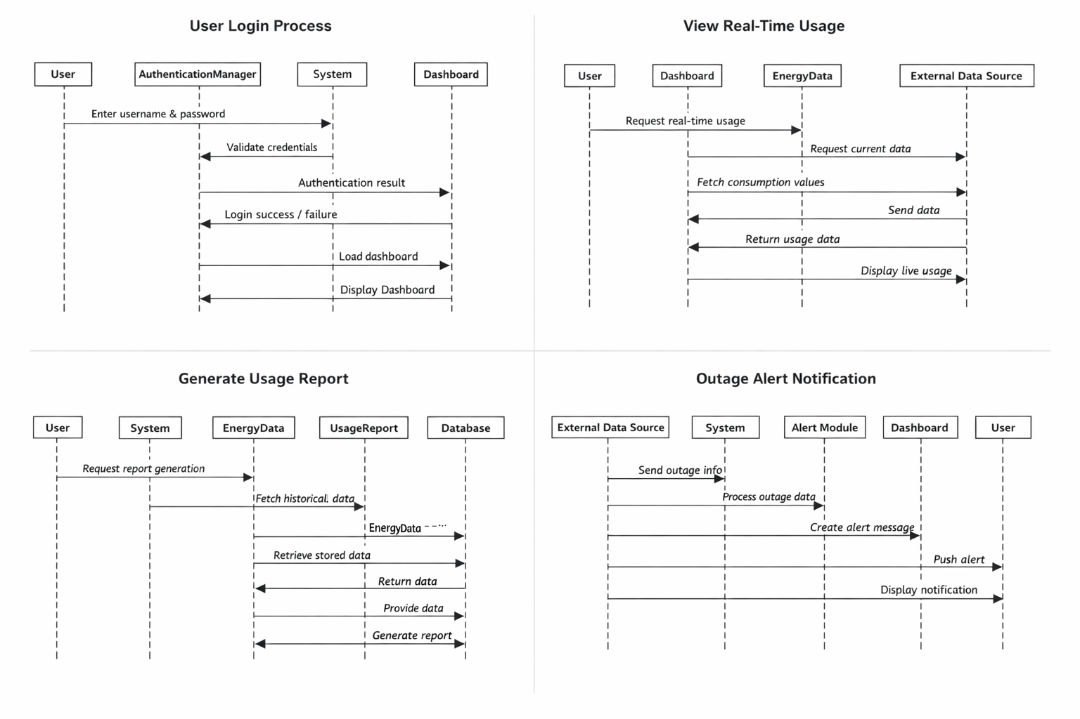

**31. Object Interactions Documentation**

An overview showing key object interactions in the system

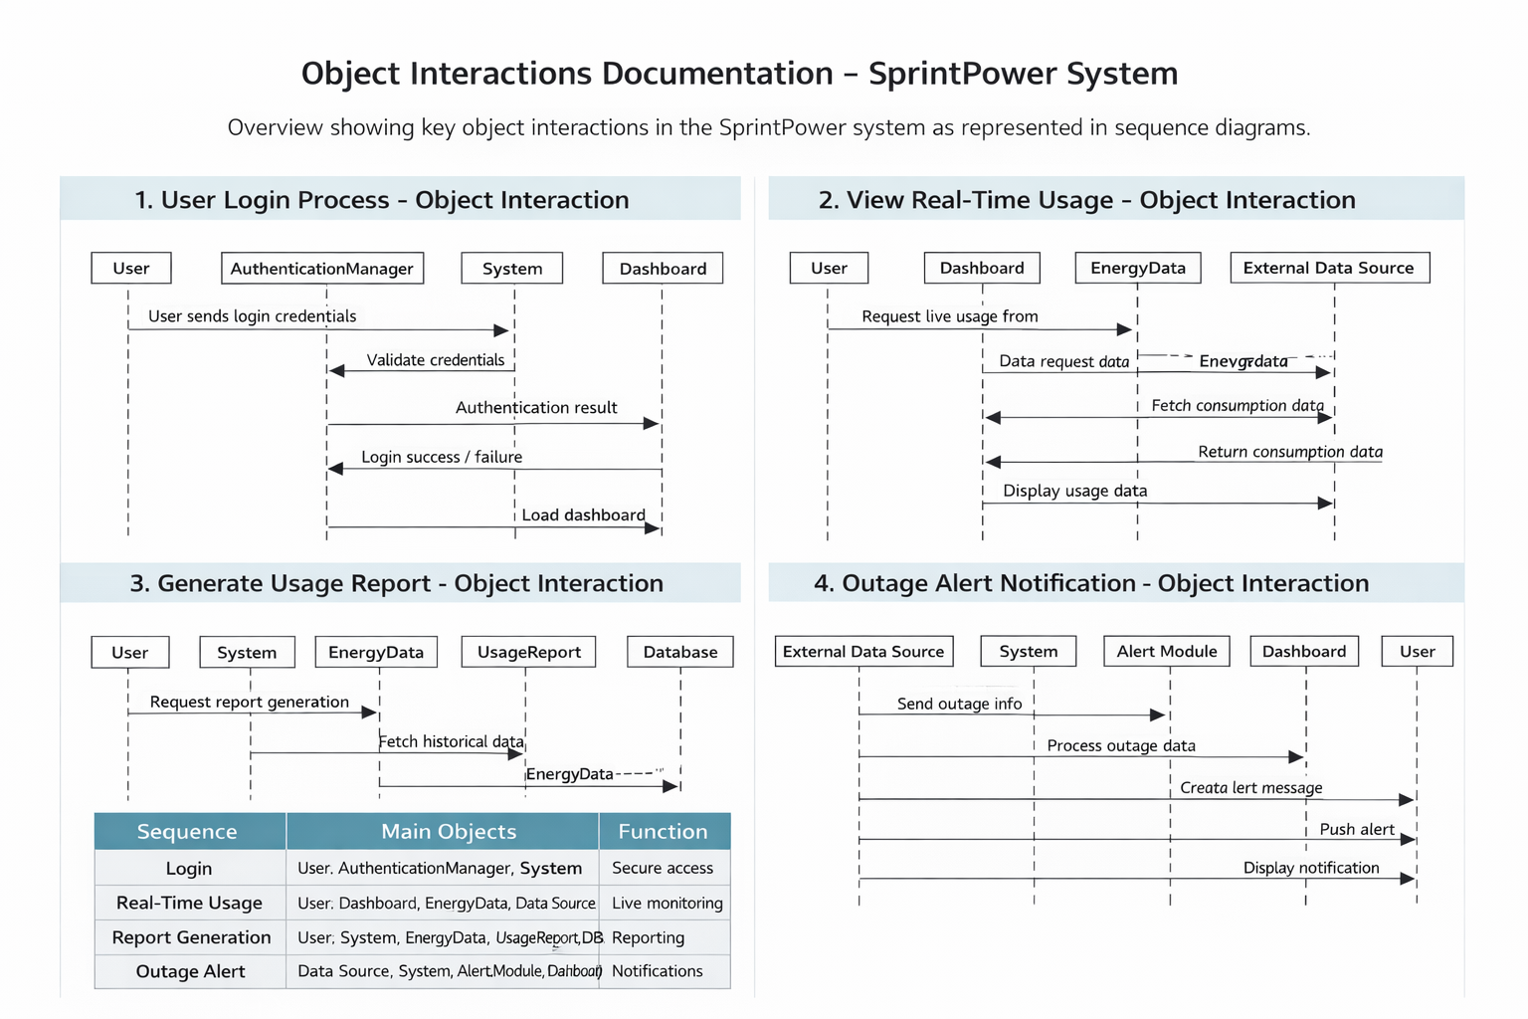

1. **Alternative Flows Inclusion**

Inclusion of alternative flows in main sequence diagrams for error handling

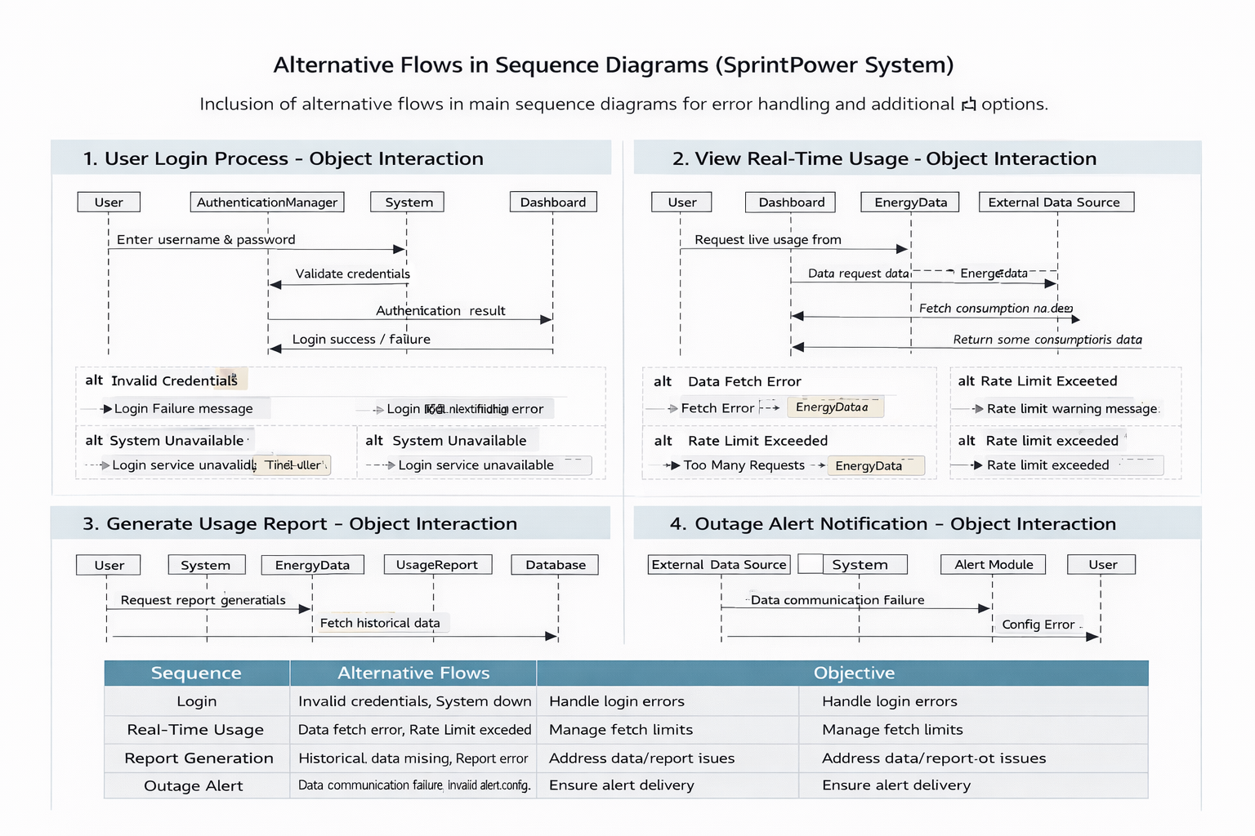

**33. Activity Diagrams Creation**

Illustrations of complex workflows for real time monitoring and outage alert notification

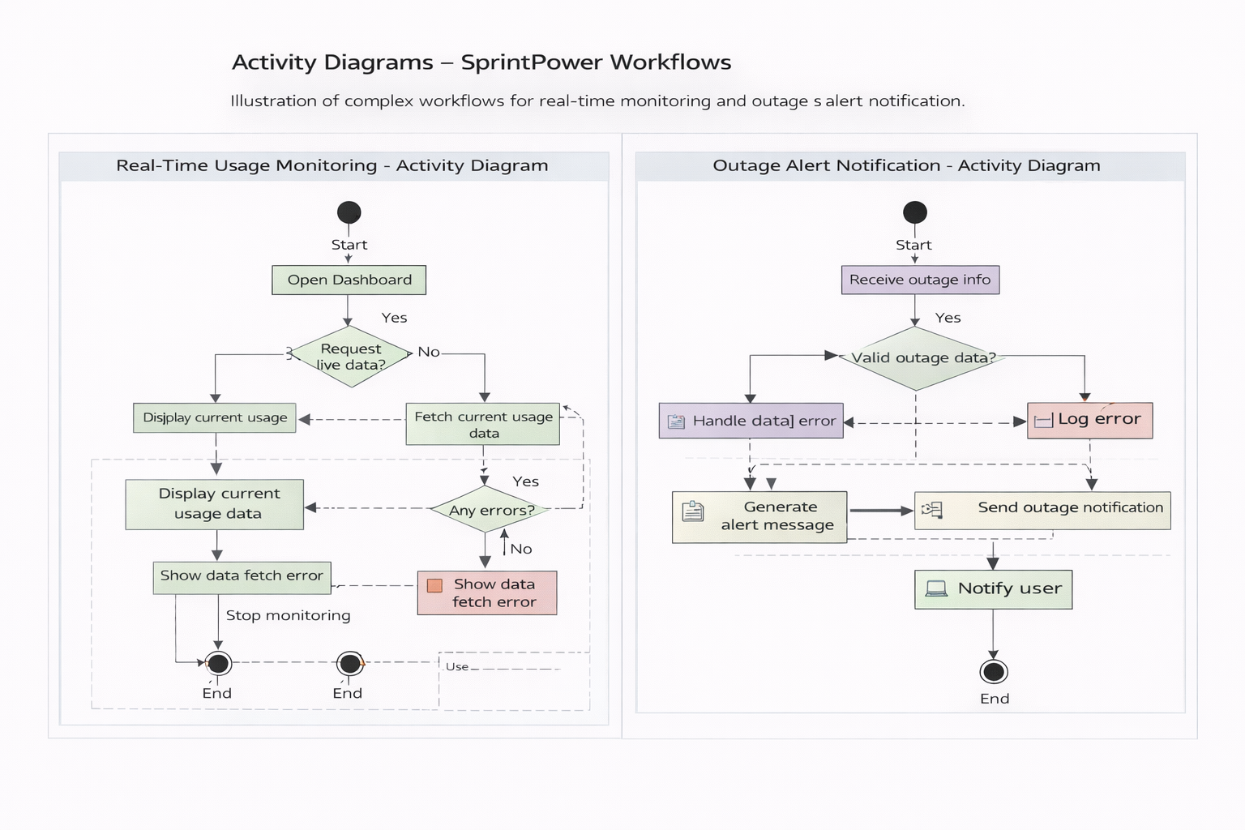

**34. Workflow Documentation**

**1. Introduction**

This document explains the complex workflows of the SprintPower system. It highlights decision points, parallel activities, and system interactions involved in major processes. The workflows help in understanding how the system behaves under different conditions.

**2. Objectives of Workflow Documentation**

The objectives are:

* To describe system behavior clearly
* To identify decision points
* To explain parallel processing
* To support testing and validation
* To improve system understanding

**3. Major System Workflows**

The following core workflows are documented:

1. User Login Workflow
2. Real-Time Usage Monitoring Workflow
3. Usage Report Generation Workflow
4. Outage Alert Handling Workflow

**4. Workflow 1: User Login and Authentication**

**4.1 Description**

This workflow manages user authentication and access control.

**4.2 Workflow Steps**

1. User enters username and password
2. System sends credentials to Authentication Module
3. Authentication Module validates credentials
4. System checks user status
5. System grants or denies access
6. Dashboard is displayed

**4.3 Decision Points**

* Are credentials valid?
* Is user account active?

**4.4 Alternative Paths**

* If credentials are invalid → Show error message
* If account is blocked → Deny access
* If server is down → Show system error

**4.5 Parallel Activities**

* Log login attempt in database
* Load user preferences

**5. Workflow 2: Real-Time Usage Monitoring**

### **5.1 Description**

This workflow handles live energy data retrieval and display.

### **5.2 Workflow Steps**

1. User requests real-time usage
2. Dashboard sends request to Usage Module
3. Usage Module fetches data from EnergyData service
4. EnergyData retrieves data from external source
5. Data is processed and validated
6. Dashboard displays updated data

### **5.3 Decision Points**

* Is data source available?
* Is received data valid?

### **5.4 Alternative Paths**

* If data unavailable → Display temporary error
* If response delayed → Retry request

### **5.5 Parallel Activities**

* Cache latest data
* Update analytics module

## **6. Workflow 3: Usage Report Generation**

### **6.1 Description**

This workflow generates historical energy reports.

### **6.2 Workflow Steps**

1. User selects report period
2. System validates request
3. System retrieves historical data
4. Database sends stored records
5. Report Module formats data
6. Report is generated
7. User downloads report

### **6.3 Decision Points**

* Is requested data available?
* Is date range valid?

### **6.4 Alternative Paths**

* If data missing → Show warning
* If report generation fails → Retry process

### **6.5 Parallel Activities**

* Generate charts
* Calculate summary statistics

## **7. Workflow 4: Outage Alert Detection and Notification**

### **7.1 Description**

This workflow manages outage prediction and alert delivery.

### **7.2 Workflow Steps**

1. External source sends outage data
2. System receives and validates data
3. Alert Module analyzes outage severity
4. Alert message is created
5. Notification is sent to users
6. Dashboard displays alert

### **7.3 Decision Points**

* Is outage confirmed?
* Is alert severity high?

### **7.4 Alternative Paths**

* If data unreliable → Ignore alert
* If notification fails → Retry delivery

### **7.5 Parallel Activities**

* Store alert history
* Update system logs

## **8. Combined Workflow: System Startup and Data Synchronization**

### **8.1 Description**

This workflow runs when the system starts.

### **8.2 Workflow Steps**

1. Server initializes services
2. Authentication Module loads user data
3. Usage Module synchronizes energy data
4. Alert Module loads configurations
5. Database establishes connection
6. System becomes operational

### **8.3 Decision Points**

* Are all services active?
* Is database reachable?

### **8.4 Alternative Paths**

* If any service fails → Restart module
* If database fails → Switch to backup

### **8.5 Parallel Activities**

* Load cache
* Initialize monitoring tools

## **9. Workflow Interaction Diagram**

User → Dashboard → Business Logic → Database → External API

↘ Analytics ↘ Logs ↘ Cache

This shows parallel data processing and logging.

## **10. Error Handling and Recovery Workflow**

### **10.1 Description**

This workflow ensures system stability during failures.

### **10.2 Steps**

1. Error detected
2. Error logged
3. User notified
4. Retry mechanism activated
5. Backup services engaged
6. System restored

### **10.3 Decision Points**

* Is error recoverable?
* Is backup available?

## **11. Benefits of Workflow Documentation**

* Improves system understanding
* Supports debugging
* Helps testers design test cases
* Improves system reliability
* Enhances project evaluation

## **12. Conclusion**

This workflow documentation describes complex SprintPower processes with decision points and parallel activities. It supports efficient development, testing, and maintenance while ensuring high system reliability and usability.

**35. Component Diagram Creation**

Overview of system architecture for monitoring system

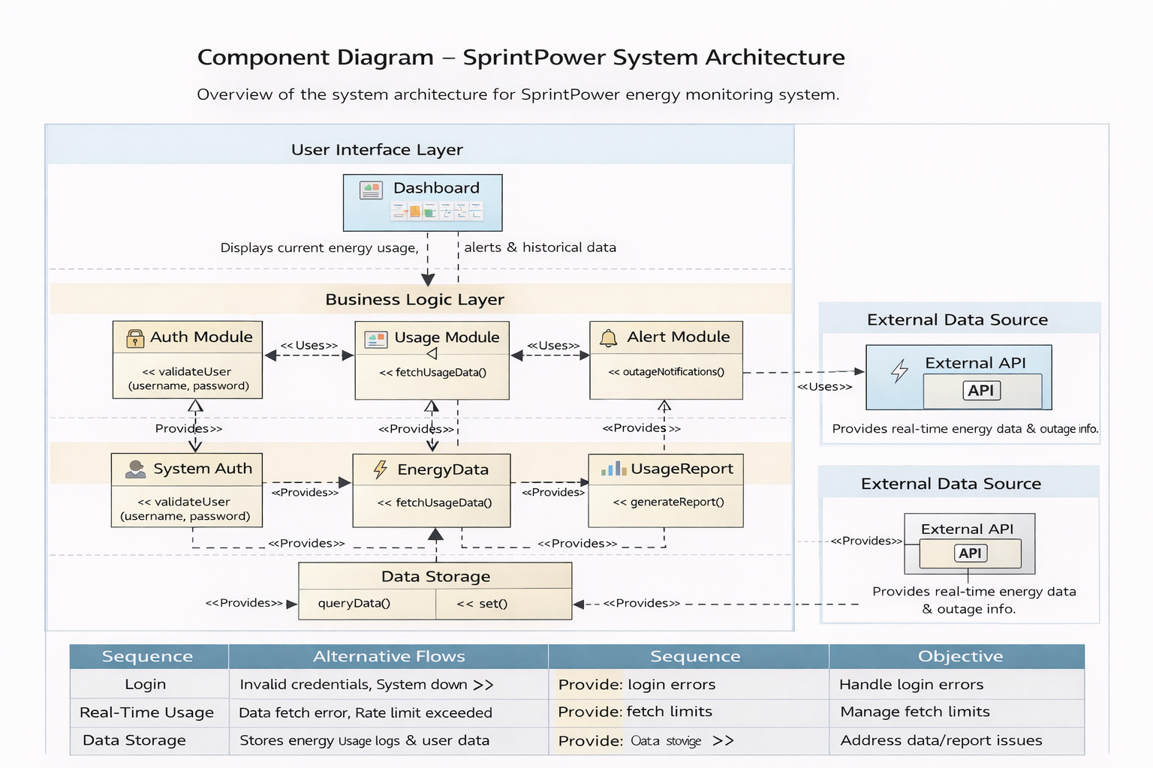

**36. Deployment Diagram Creation**

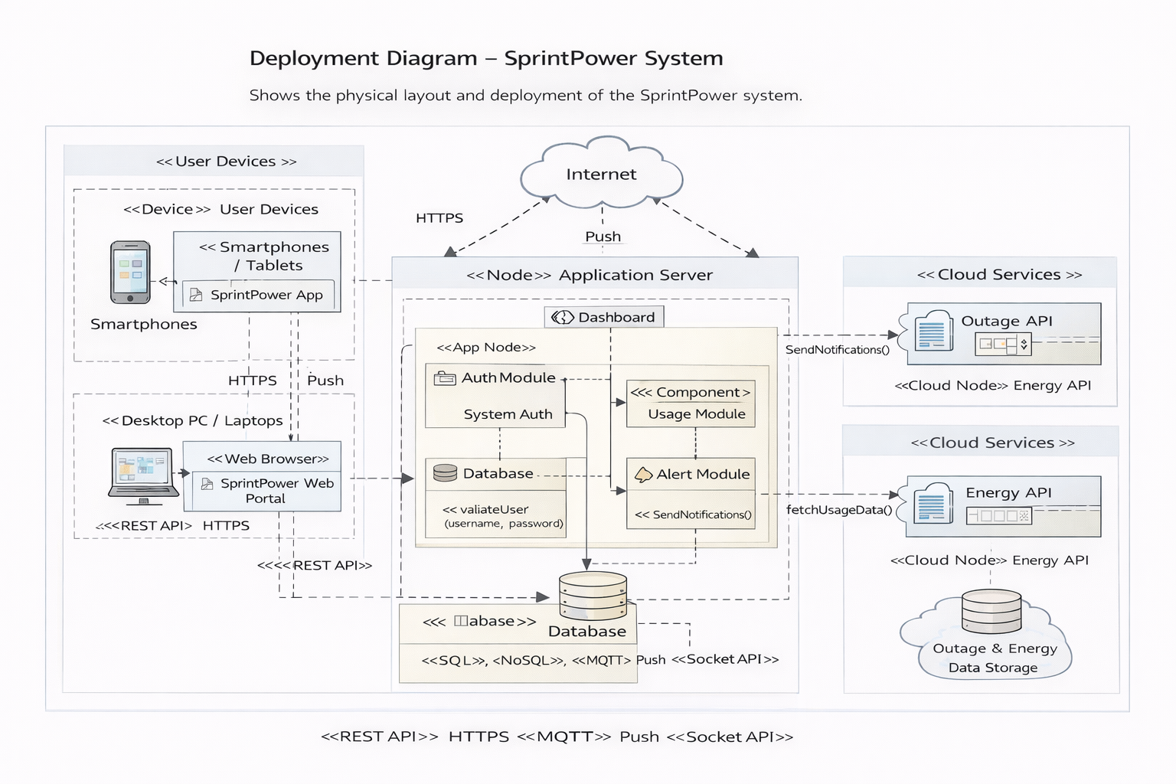

**37. Design Document Creation**

## **1. Introduction**

This design document describes the architectural and technical design decisions made during the development of the SprintPower system. It explains how the system components are structured and how they work together to achieve project objectives.

## **2. Design Objectives**

The main objectives of the system design are:

* To provide real-time energy monitoring
* To ensure secure user authentication
* To enable reliable alert and report generation
* To support scalability and maintainability
* To ensure high system availability
* To simplify future enhancements

## **3. System Architecture Overview**

SprintPower follows a three-layer architecture:

1. User Interface Layer
2. Business Logic Layer
3. Data Management Layer

This layered architecture improves modularity, security, and ease of maintenance.

## **4. Architectural Design Decisions**

### **4.1 Layered Architecture**

A layered architecture was selected to separate concerns and reduce system complexity.

* UI Layer handles user interaction
* Business Layer processes data and rules
* Data Layer manages storage and retrieval

This improves code reusability and system stability.

### **4.2 Client–Server Model**

The system uses a client–server architecture where:

* Clients access the system through web browsers or mobile devices
* The server processes requests and manages data

This model supports centralized control and easier updates.

## **5. Component Design Decisions**

### **5.1 Authentication Module**

Purpose:

* Validates user credentials
* Prevents unauthorized access

Reason:

Security is critical for protecting user data.

### **5.2 Usage Monitoring Module**

Purpose:

* Fetches and processes energy consumption data
* Displays real-time information

Reason:

Core feature of the system for monitoring usage.

### **5.3 Alert Module**

Purpose:

* Generates outage and abnormal usage alerts
* Sends notifications

Reason:

Improves user preparedness and reliability.

### **5.4 Report Generation Module**

Purpose:

* Generates downloadable reports
* Provides historical analysis

Reason:

Helps users understand long-term consumption patterns.

## **6. Database Design Decisions**

The database stores:

* User profiles
* Energy consumption data
* Alert logs
* Report history

### **6.1 Database Type**

A relational database (SQL) is selected for:

* Data consistency
* Structured storage
* Easy querying

Optionally, NoSQL storage may be used for large-scale data in future.

## **7. Security Design Decisions**

Security measures include:

* Encrypted passwords
* Secure login authentication
* HTTPS communication
* Role-based access control

These measures protect user privacy and system integrity.

## **8. Performance and Reliability Design**

### **8.1 Performance**

* Efficient data caching
* Optimized database queries
* Load balancing (future scope)

### **8.2 Reliability**

* Backup mechanisms
* Error handling modules
* Recovery procedures

These ensure system stability and minimal downtime.

## **9. Interface Design Decisions**

### **9.1 User Interface**

The UI is designed to be:

* Simple
* Responsive
* Easy to navigate

Dashboards use charts and summaries for better understanding.

### **9.2 System Interfaces**

The system communicates using:

* REST APIs
* Secure protocols (HTTPS)
* External APIs for energy data

## **10. Deployment Design Decisions**

The deployment model includes:

* Client devices (browser/mobile)
* Application server
* Cloud-based database
* External data services

This supports scalability and remote access.

## **11. Alternative Flow and Error Handling Design**

The system supports alternative flows such as:

* Invalid login credentials
* Data fetch failure
* Server unavailability
* Network issues

Error messages and retry mechanisms improve user experience.

## **12. Scalability and Maintainability**

### **12.1 Scalability**

The system is designed to:

* Support multiple users
* Handle growing data volume
* Allow cloud deployment

### **12.2 Maintainability**

* Modular components
* Well-documented code
* Agile-based updates

These enable easy maintenance and upgrades.

## **13. Technology Selection Rationale**

|  |  |  |
| --- | --- | --- |
| **Layer** | **Technology** | **Reason** |
| Frontend | HTML, CSS, JavaScript | Simple and responsive UI |
| Backend | Node.js / Python | Fast processing |
| Database | MySQL / MongoDB | Reliable storage |
| APIs | REST | Easy integration |

## **14. Limitations and Constraints**

* Limited academic timeline
* Simulated data source
* Resource constraints
* No direct hardware integration

These influenced simplified design choices.

## **15. Future Enhancements**

Planned improvements include:

* AI-based forecasting
* Mobile application
* Smart meter integration
* Advanced analytics

## **16. Conclusion**

This design document explains the major design decisions of the SprintPower system. The selected architecture and components ensure security, scalability, reliability, and usability while meeting academic project requirements.